|  |  |
| --- | --- |
| **EWULogo.png** | **EAST WEST UNIVERSITY** |
| **Department of Computer Science and Engineering** |
| **B.Sc. in Computer Science and Engineering Program** |
| **Final, Fall 2021** |

|  |  |
| --- | --- |
| **Course:** | **CSE246 (Algorithms), Section - 1** |
| **Instructor:** | **Taskeed Jabid** |
| **Full Marks:** | **25** |
| **Time:** | **1 Hour and 15 Minutes + 15 Minutes** |

**Note:** There are FIVE questions, answer ALL of them.

***In some question, you need to choose some input data. I expect that no input data set will be same with any other script.***

1. Select some 2D points and show the working procedure of Graham Scan algorithm to find the convex polygon. Clearly mention which points are in the stack after each iteration.
2. Assign weight of the edges of the following graph from the set of integers ranging from 1 to 15. Run the Dijkstra shortest path algorithm on the following graph, starting from vertex A.

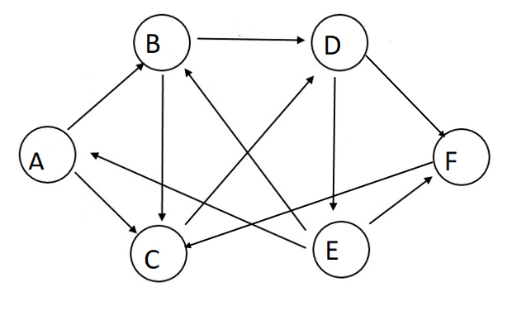

|  |  |  |  |  |  |  |
| --- | --- | --- | --- | --- | --- | --- |
| **Iteration/Vertex** | **A** | **B** | **C** | **D** | **E** | **F** |
| **0** | **0/NIL** | **Infinity/NIL** | **Infinity/NIL** | **Infinity/NIL** | **Infinity/NIL** | **Infinity/NIL** |
| **1** |  |  |  |  |  |  |
| **2** |  |  |  |  |  |  |
| **3** |  |  |  |  |  |  |
| **4** |  |  |  |  |  |  |
| **5** |  |  |  |  |  |  |
| **6** |  |  |  |  |  |  |

1. Draw a graph (with at least 6 nodes) where multiple MST exists. Show which one will be given by Kruskal algorithm.
2. Choose the best answer from the following questions
   1. What is the shortest path from node A to node F?

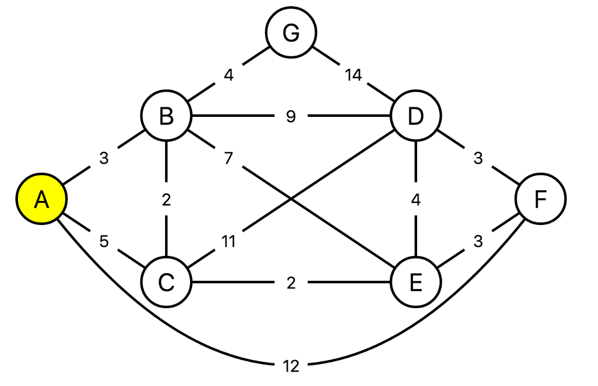

* + 1. A -> B -> D -> F
    2. A -> C -> B -> E -> F
    3. A -> F
    4. A -> C -> E -> F
  1. Using the graph from the previous question, if we apply Dijkstra's algorithm to find the shortest distance between node A and all the others, in what order do the nodes get included into the visited set (i.e. their distances have been finalized)?
     1. B C F G E D
     2. B C G E F D
     3. C B E F G D
     4. C B E G F D
  2. What is the basic principle in Rabin Karp algorithm?
     1. Hashing
     2. Sorting
     3. Augmenting
     4. Dynamic Programming
  3. Complete the program.

n=rows[W]

D(0)=W

for k=1 to n

do for i=1 to n

do for j=1 to n

do ________________________________

return D(n)

* + 1. dij(k)=min(dij(k-1), dik(k-1) – dkj(k-1))
    2. dij(k)=max(dij(k-1), dik(k-1) – dkj(k-1))
    3. dij(k)=min(dij(k-1), dik(k-1) + dkj(k-1))
    4. dij(k)=max(dij(k-1), dik(k-1) + dkj(k-1))A
  1. A graph is said to have a negative weight cycle when?
     1. The graph has 1 negative weighted edge
     2. The graph has a cycle
     3. The total weight of the graph is negative
     4. The graph has 1 or more negative weighted edges

1. Write down the truthfulness of the following statements
   1. Stack is the most commonly used data structure for implementing Dijkstra’s Algorithm?
   2. Dijkstra’s Algorithm cannot be applied on Unweighted graphs
   3. Every graph has only one minimum spanning tree.
   4. Consider a complete graph G with 4 vertices. The graph G has (4*2=8) spanning trees.
   5. Rabin and Karp Algorithm is String Matching Algorithm